Chinmay Sir Topics & Questions

ques
- What is n-bit processor?
A microcontroller or processor is called 'N-bit' because controllers and processors have a fundamental data width. Each register might be N bits, each instruction might be N bits, the data bus might be N bits, the memory might be addressed with N bits.

- describe the relationship among hardware, software and firmware.
https://theintactone.com/2019/10/12/cf-u4-topic-2-relationship-between-hardware-and-software/

- Mention the function of 8086 queue.

In 8086, a 6-byte instruction queue is presented at the Bus Interface Unit (BIU). It is used to pre fetch and store at the maximum of 6 bytes of instruction code from the memory. Due to this, overlapping instruction fetch with instruction implementation increases the processing speed.

The processor executes a program by fetching the instructions from memory and executing them. Usually the processor execution speed is much faster than the memory access speed. Instruction queue is used to prefetch the next instructions in a separate buffer while the processor is executing the current instruction.
In 8086, a 6-byte instruction queue is presented at the Bus Interface Unit (BIU). It is used to prefetch and store at the maximum of 6 bytes of instruction code from the memory. Due to this, overlapping instruction fetch with instruction execution increases the processing speed.

The execution unit (EU) is supposed to decode or execute an instruction. When EU is busy in decoding and executing an instruction, the BIU fetches up to six instruction bytes for the next instructions. These bytes are called as the pre-fetched bytes and they are stored in a first in first out (FIFO) register set, which is called as a queue.
The fetching of opcodes well in advance, prior to their need for execution increases the overall efficiency of the processor boosting its speed. The processor no longer has to wait for the memory access operations for the subsequent instruction opcode to complete.
Instruction queue is 6 bytes so that it can store the longest instruction.
8086 is the 1st processor to support Instruction Queue.
- 8086 is a 16-bit microprocessor, but its memory mapping is 20 bits. How it is possible?
8086 is a 16 bit microprocessor that means its arithmetic logic unit can execute 16 bit multiple instruction at a time and it's internal registers most of the instructions are 16 bits.

But 8086 has 20 bit address bus means it can address any one of 2^20 = 1 MB memory locations.
The BIU (Bus Interface Unit) of the CPU consists of four segment register. Upper 16 bits of the starting address for that segment.

In BIU, pointer registers also called offset consists the distance from the base address to the next instruction byte to be fetched.

To make from 16 bit to 20 bit memory address the BIU automatically inserts zeroes for the lowest 4 bits of the segment base address, then the IP is added to the code segment(CS). Then the 16 bit offset is added to the segment. Thus 20 bit memory mapping is possible.

For example,
If the CS register contains 348AH, the starting address for the code segment is 348A0H (Here 0 is appended)

If IP is 4214H, then the 20 bit physical address of memory is

CS = 348A0H
IP = 4214H
-------------------------------------------
Physical address = 38AB4H

This is why 8086 memory mapping is 20 bits.

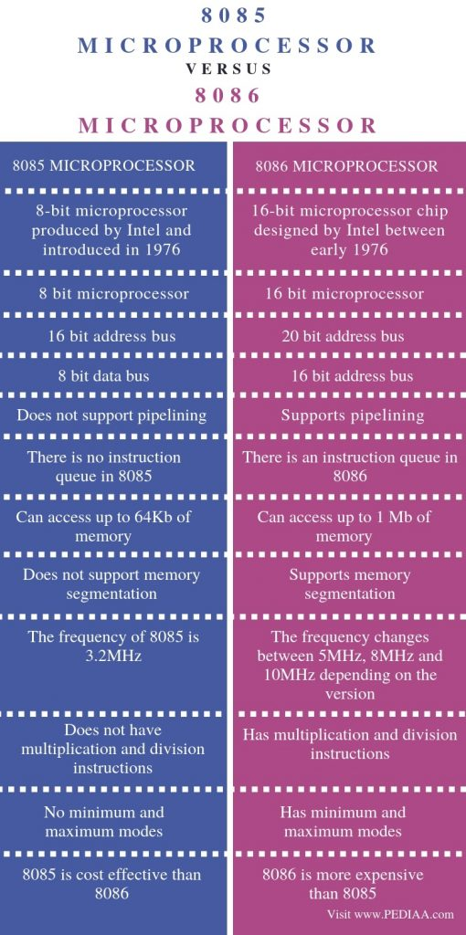
- Give the flag status of the flag register after performing this multiplication = 3B*A
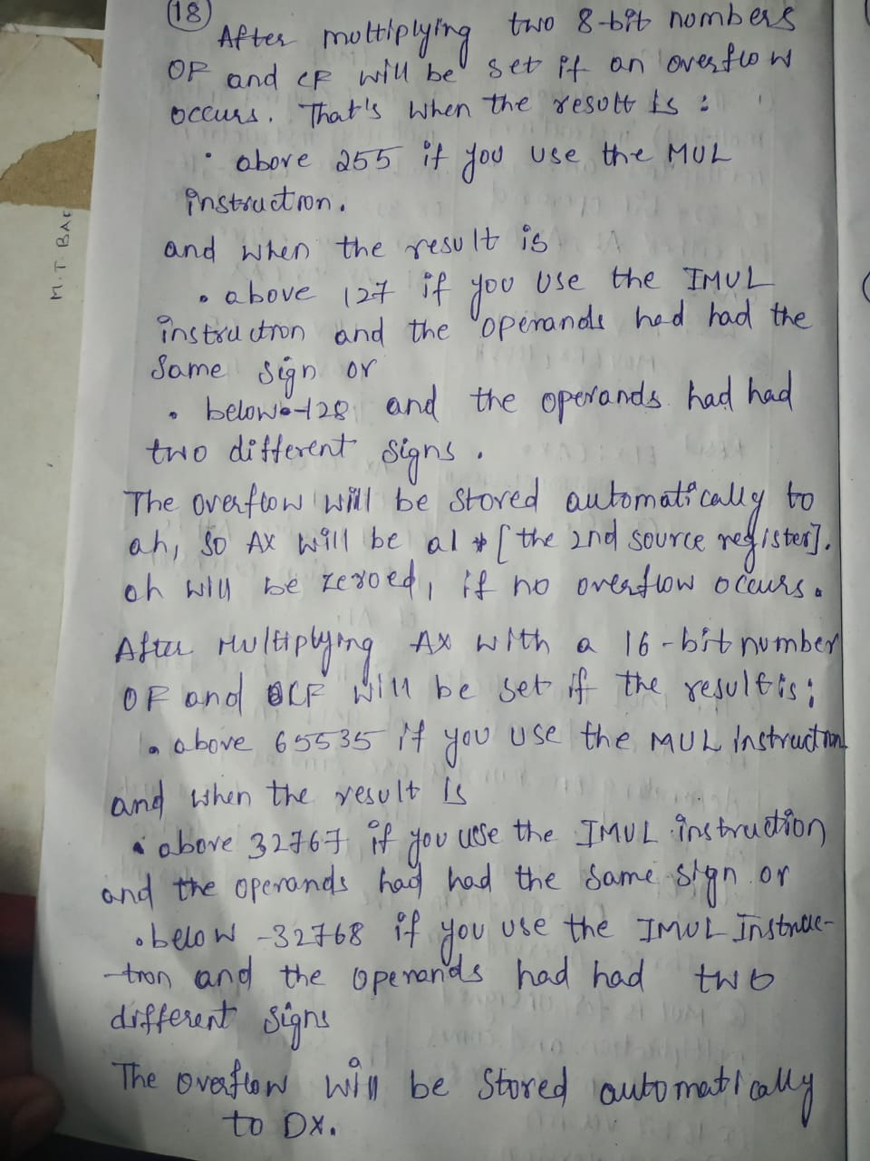

82C55 PPI
6. How can the two groups [A, B] of ports of 82C55 be programmed?
Answer:
The 82C55 PPI has two groups of ports — Group A (Port A and upper Port C) and Group B (Port B and lower Port C).
Each group can be programmed independently in any of the available modes:
- Mode 0: Simple input/output
- Mode 1: Input/output with handshaking
- Mode 2: Bidirectional data transfer (only for Port A)
The control word register determines how each port operates.

7. The continuous motor is familiar to us, but the stepper is a digital motor. Why it is digital? How it can be operated through 82C55 PPI?
Answer:
A stepper motor is called a digital motor because it moves in discrete steps rather than continuous rotation — each pulse moves it by a fixed angle.
Using 82C55 PPI, we can operate a stepper motor by:
- Sending binary patterns to the motor’s control lines through Port A or Port B.
- Each output pattern energizes the coils sequentially to make the motor rotate step-by-step.
Thus, digital signals from the PPI control the motor’s position and direction precisely.

8. Briefly describe 82C55 PPI.
Answer:
The Intel 82C55 Programmable Peripheral Interface (PPI) is a general-purpose I/O device that interfaces a microprocessor with external devices like keyboard, display, ADC/DAC, or motor.
It has three 8-bit ports (Port A, B, and C), which can be configured as input or output in different modes (0, 1, 2) using a control word.
It provides flexible interfacing between CPU and peripherals without complex hardware.

9. Shortly describe 82C55 PPI. How it can be programmed?
Answer:
The 82C55 PPI provides 24 I/O pins divided into Port A, B, and C.
It is programmable through a control word written into its control register.
This control word sets:
- Input/output direction of each port
- Operating mode (Mode 0, 1, or 2)
Programming is done by sending a proper 8-bit control word from the CPU to define how each port will function.

10. Explain mode 1 operation and mode 2 operations of 82C55.
Answer:
Mode 1 – Input/Output with Handshaking:
- Provides strobed I/O using handshake signals for synchronized data transfer.
- Each group uses part of Port C for control signals.
- Ensures data is transferred only when both devices are ready.
- Example: Used for interfacing with printer or keyboard.
Mode 2 – Bidirectional Data Transfer:
- Available only for Port A (Group A).
- Allows two-way communication using handshake lines from Port C.
- Data can flow both to and from the peripheral using proper synchronization.
- Example: Used for data exchange between two microprocessors.

Coprocessor
1. Why coprocessor is used in computer systems?
Answer:
A coprocessor is used to increase the performance of a computer by handling specialized tasks like arithmetic, floating-point operations, or signal processing.
It offloads these tasks from the main CPU, allowing faster and more efficient processing.

2. What is the difference between coprocessors and peripheral devices?
Answer:
Coprocessor | Peripheral Device
Works closely with the CPU to perform computation tasks. | Performs input/output or external communication.
Shares memory and instruction control with the main CPU. | Controlled by I/O commands, not part of CPU operations.
Example: 8087 Math Coprocessor. | Example: Keyboard, printer, disk drive.

3. How can the coprocessor interface with the main processor?
Answer:
The coprocessor interfaces with the main processor through a bus interface using:
- Shared system buses (data, address, control).
- Special control signals like TEST, BUSY, and READY.
It synchronizes operations using these signals and executes coprocessor instructions embedded in the main program.

4. Briefly describe a numeric coprocessor.
Answer:
A numeric coprocessor (or math coprocessor) is a hardware unit that performs floating-point arithmetic, logarithmic, and trigonometric calculations faster than the CPU.
Example: Intel 8087, used with the 8086 processor, executes complex math functions using an internal stack-based architecture.

5. Why coprocessor is used in computer systems? How does the coprocessor interface with the main processor?
Answer:
A coprocessor is used to enhance processing speed for mathematical or logical tasks that are difficult for the CPU.
It interfaces with the main processor through shared buses and control signals, executing special coprocessor opcodes that the CPU recognizes but passes to the coprocessor for execution.

6. “All coprocessors are peripherals, but all peripherals are not coprocessors.” Explain this statement.
Answer:
All coprocessors are peripheral devices because they connect externally to the CPU and assist it.
However, not all peripherals (like printers, keyboards, or monitors) perform computation — hence, they are not coprocessors.
Only devices that enhance CPU computation qualify as coprocessors.

7. Explain about 8087 coprocessors.
Answer:
The Intel 8087 is a numeric coprocessor designed to work with the 8086/8088 CPU.
It performs floating-point arithmetic, exponential, logarithmic, and trigonometric operations.
It uses a stack of 8 registers (ST0–ST7) and operates in parallel with the CPU using a synchronized bus interface.

8. Distinguish between 8086 and 8087 coprocessors.
Answer:
8086 | 8087
General-purpose microprocessor. | Numeric (math) coprocessor.
Executes integer and control operations. | Executes floating-point and complex math.
Can work independently. | Works alongside 8086; depends on it for instruction flow.
ALU handles integer arithmetic. | Dedicated FPU (Floating Point Unit).

9. Mention 6 processors with their corresponding coprocessors.
Answer:
Main Processor | Coprocessor
8086 | 8087
80286 | 80287
80386 | 80387
80486 | Built-in FPU (no external coprocessor)
Pentium | Integrated FPU
ARM Cortex-M | Floating Point Unit (FPU)
.

Early Calculating Devices
- Abacus (500 BC): First mechanical calculator used by Babylonians.
- Blaise Pascal (1642): Invented a mechanical calculator with gears, known as the Pascaline.
- Charles Babbage (1830s): Conceptualized the Analytical Engine, a steam-powered mechanical computer using punched cards for programming, influencing later computing designs.

The Electrical Age
- Herman Hollerith (1889): Invented the punched card system for data storage and tabulation, used in the 1890 US Census. His company later became IBM.
- Konrad Zuse (1941): Developed the Z3, the first electromechanical computer, used for aircraft and missile design.
- Alan Turing (1943): Created Colossus, an electronic computer used to break German military codes in WWII.

The First General-Purpose Electronic Computers
- ENIAC (1946): The first general-purpose programmable electronic computer with 17,000 vacuum tubes.
- Transistor (1947): Development of the transistor marked the beginning of smaller, more reliable computers.
- Integrated Circuits (1958): Invention by Jack Kilby allowed for more compact and faster computers.

Microprocessor Revolution
- Intel 4004 (1971): First microprocessor, a 4-bit processor addressing 4,096 memory locations.
- Intel 8080 (1973): The first 8-bit microprocessor, much faster than the 4004.
- Intel 8086 (1978): The first 16-bit microprocessor, leading to the x86 architecture, and used in the first IBM PCs.

Advancements in Programming
- Machine Language: Early programming was in binary machine language.
- Assembly Language (1950s): Mnemonic codes like ADD replaced binary.
- FORTRAN (1957): First high-level programming language for scientific computations.
- COBOL: Popular for business applications.
- C/C++: Key in modern software development for control over hardware.

Modern Microprocessors
- Intel 80386 (1986): First 32-bit microprocessor, addressing up to 4GB of memory.
- Intel Pentium (1993): Introduced the superscalar architecture, allowing simultaneous execution of multiple instructions.
- Pentium II/III (1997/1999): Improved performance with increased clock speeds and cache sizes.
- Intel Core2 (2006): A significant leap in multi-core processors for higher processing power.

Performance and Memory
- Cache Memory: Key to improving speed by storing frequently accessed data.
- 64-bit Microprocessors: Modern processors (like Intel Core2) address more than 4GB of memory.

Multiple Cores and Hyper-Threading
- Dual/Quad Cores: Intel introduced multiple cores (e.g., Core2) to handle parallel processing.
- Hyper-threading: Technology allowing simultaneous execution of multiple threads by a single core.

Future Trends
- Faster Processors: The shift from increasing clock speeds to adding more cores for parallel processing.
- Flash Memory: Potential future replacement for traditional hard drives for faster data storage.

